OUR IRVINE
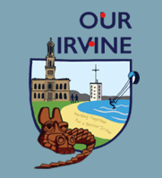
Irvine Neighbourhood Board invites applications for

THE IRVINE GRANT
UP to & INCL £5,000
APPLICATION FORM AND GUIDANCE NOTES

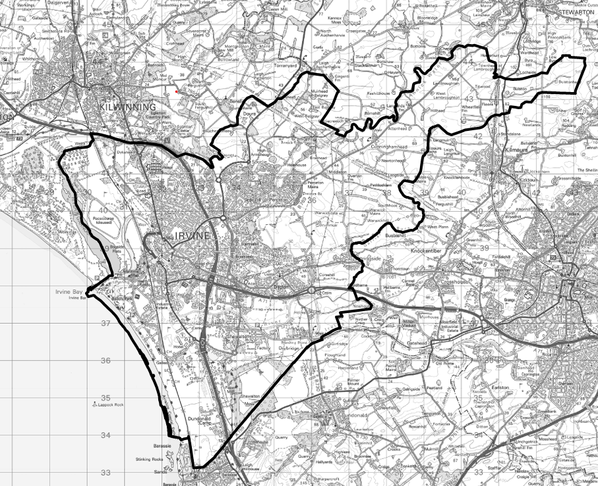

1.0 GUIDANCE & CONTACT DETAILS
The Irvine Grant is an Irvine-only, fund to enable locally led action to deliver priorities identified in the Irvine PfN 10-year Regeneration Plan. Priority will be given to applications from local “not for profit” grassroots community groups, voluntary organisations, third sector organisations, CICs and registered charities.

The grant is for REVENUE only funding for NEW projects. Existing posts will NOT be supported. The Grant may support one element of a larger project, excluding projects which are already underway.
After the applications have been assessed we will let you know if you have been successful or not. Please complete the following form. Guidance will be provided for each question.
Should you have any queries or require any assistance completing the form please contact irvinegrant@ourirvine.scot
Once complete please return the form to irvinegrant@ourirvine.scot by Sunday 22nd November 2026.
1.1 Name of organisation

1.2 Charity/Company Number if applicable

1.3 Contact name

1.4 Contact address

1.5 Contact number

1.6 Contact email address

2.0 GRANT REQUEST
2.1 Total amount of funding being requested

2.2 If your application is successful will this fully fund your project?
YES/NO
2.3 If no, what is the full cost of the project and how will the remainder be funded?

Match funding (actual or planned) and doing your project along with another group are not essential for the grant but will be looked at more favourably.
2.4 Please provide the name of any other group or organisation involved in the project.

2.5 Please provide evidence of match funding and whether it is secured or planned?

You can also tell us about these below in the Project Costs section of the application form.
Please complete the template below, providing a breakdown of costs
Cost description (2027/28) | Total Cost (£) | Amount requested (£)
TOTAL
Total project cost - only non-recoverable VAT should be included, as part of the relevant project costs
The panel can decide to offer a lower level of grant than requested based on the information submitted.
Costs for your project are only eligible to claim for if your application is successful. Any spend before you are told the outcome of your application will not be paid.
We will ask you ask you to submit quotes for any goods or services required to demonstrate “best value”. Submission of quotes will depend on the nature of the project and will be communicated to applicants with the notification of the application outcome.

3.0 ELIGIBILITY CRITERIA
We are aware that different organisations are at different stages and we would really like to know what your rules and policies are. Aside from specific requirements (in RED such as the requirement to comply with Fair Work First) what we are looking for here is an understanding of your organisational rules and principles, for example, a Constitution, Standing Orders and Terms of Reference, Membership Rules or minutes from your meetings.
3.1 Please check all the boxes below which apply to your organisation:
☐ We are a local group or organisation made up of local people providing services and/or activities making a difference in our communities.
☐We are based within the Irvine boundary map illustrated.
☐Our work/project will benefit communities within the boundary map illustrated.
☐We have a minimum of three members.
☐We have Registered Charity Status.
☐We have a written constitution.
☐We have a written set of rules/minutes of meetings
☐We have a bank account held in our name
☐GDPR ☐Prevent Duty
☐Fair Work First ☐Disclosure Scotland

You will be required to submit all relevant paperwork such as your constitution, any accreditation and any safeguarding documentation, prior to a formal Offer of Grant.

4.0 GRANT OBJECTIVES
PiP Intervention Area: Cohesion
The project must meet at least one of the below objectives
Which of these objectives best describes your project:
Tick all that apply:
☒Support staffing of community facilities
☐Increased community action
☐Wealth building & ability to keep providing services and/or activities
☐Strengthening sense of community and belonging
☐Reducing inequalities
☐Minimising anti-social behaviour

Potential output examples:
- Plans which identify local issues about the community working together and what your project would do to address this.
- Projects that bring people together from different communities.
- Projects which celebrate and explore different cultures and lives, such as neighbourhood festivals and cultural exchange opportunities.
- Projects which build relationships within and between communities, such as mentoring and buddying schemes, town-hall discussions on local issues, and creating conversations.
- Supporting or establishing community groups with the goal of bringing people together and reducing social isolation and loneliness.
- Projects which increase the community’s ability to deal with issues like tackling hate crime and misinformation which divides rather than brings people together.

5.0 WHAT IS THE FUNDING FOR?
Explain your project in detail, including:
5.1 Background. Please describe your current activity in Irvine.

5.2 Project Name

5.3 Project Location. What area(s) of Irvine will benefit from the project? (one or more). Where will the project be delivered? Tick as many as are applicable.
☐Town Centre & Harbourside
☐Bourtreehill & Broomlands
☐Girdle Toll
☐Lawthorn
☐Castlepark
☐Fullarton
☐Dreghorn & Springside
5.4 Project Start Date

5.5 Project Completion Date

5.6 Project Description. What will you do with the funding requested? How you will achieve the proposed outcomes. Describe the project as if you are telling someone who does not know anything about it and provide as much detail as you can about the project, what objectives it will deliver and who will benefit from it. if you are working with any other partners, please tell us about this.
Tell us why your proposal is the best way to deal with the issue your project is tackling. Have you asked your local community, and do you have answers that you can share with us that shows this, for example surveys or questionnaires. You need to prove that your proposal is good value for money and that it is cost-effective.

5.7 Who is the project for? Who will benefit from the project? Who is your target group?
Your answer(s) here will not impact on your score so long as you demonstrate the need for your community.
☐whole community
☐young people
☐women
☐ethnic minorities
☐people with a disability
☐older age groups
☐unemployed
☐local businesses
☐low-income households
Other…………………………………………………………………………………………………………………
5.8 Project Targets. How many people will you be able to help through your project?

- DELIVERABILITY
6.1 Risk Assessment. To assess applications fully, we need to understand what arrangements are in place to carry the project out and what might stop the project from happening? We will be looking to see that your activity is fully planned out and carefully budgeted. You must have all the appropriate insurances in place that you need to run the project.

6.2 Financial Management. Your group/organisation must have finances that are enough to run your organisation i.e. you must be financially viable. Who will be looking after the grant money? Who will be running the project? Staff or volunteers or both?

In carrying out the project, the applicant will be expected to be aware of and promote the Fair Work Framework. Organisations should be encouraged to work toward implementing the Fair Work First criteria in a way that reflects the size of their organisation.

7.0 MONITORING AND REPORTING
You must make sure that you are able to prove your funded project can demonstrate that you have met whatever targets you have stated on this application and be able to report on this and the progress of the project to the Irvine Town Board (ITB) both during the project and at the end of the project.
7.1 Tell us how you plan to monitor and evaluate the project. You will be asked to report on whatever targets and impact you have stated in your application. How have you used the grant and how does the grant help the project to happen?

8.0 ASSESSMENT
Applications proceeding to full assessment will be reviewed and scored by an assessment group/panel comprising members of the Irvine Town Board. Successful applications will be ratified by the full Board.
Applications will be scored on the following 5 aspects:
- Project Detail: How your project will meet the Plan for Neighbourhoods outcomes.
- Evidence of Need: Show the need for your project.
- Measurement of Success: Show clear targets that meet the Plan for Neighbourhoods outcomes.
- Long Term Benefits: Show how the project could keep going and even develop after the funding has ended.
- Collaboration/Match Funding: Show any additional funding you have or may be applying for to run your project.

8.0 SUBMISSION
Applicants should note the content of the Data Protection Statement.
By signing the application form, the authorised signatory, confirms for and on behalf of the applicant that the applicant has read and understood the Guidance and declares that to the best of the applicant’s knowledge and belief, the information given in the application form and any supporting documentation is correct and accurate.
The applicant understands that acceptance of this application by the ITB does not itself guarantee that a grant will be offered.
The applicant is aware that the project must be completed by the date noted.
Authorised Signatory……………………………………………………………………………………………………..
Date……………………………………………………………………………………………………………………………….
No approval of this application or any related documentation will impose or be deemed to impose any liability whatsoever on the ITB, as to its accuracy or otherwise and any offer of any grant by the ITB to the applicant is made purely in the ITBs capacity as grant funder, under the Irvine Plan for Neighbourhood.

Completed and signed applications must be submitted to the following address: - (Should you require assistance with your application form please contact the address below)

irvinegrant@ourirvine.scot

FAO Irvine Neighbourhood Board, Pride in Place Programme, c/o Regeneration, Connected Communities, 2nd Floor, Cunninghame House, KA12 8EE

by

Sunday 22nd November 2026

Decisions will be made at the Irvine Neighbourhood Board Meeting on 9th December 2026 and both successful and unsuccessful applicants shall be notified shortly thereafter.

